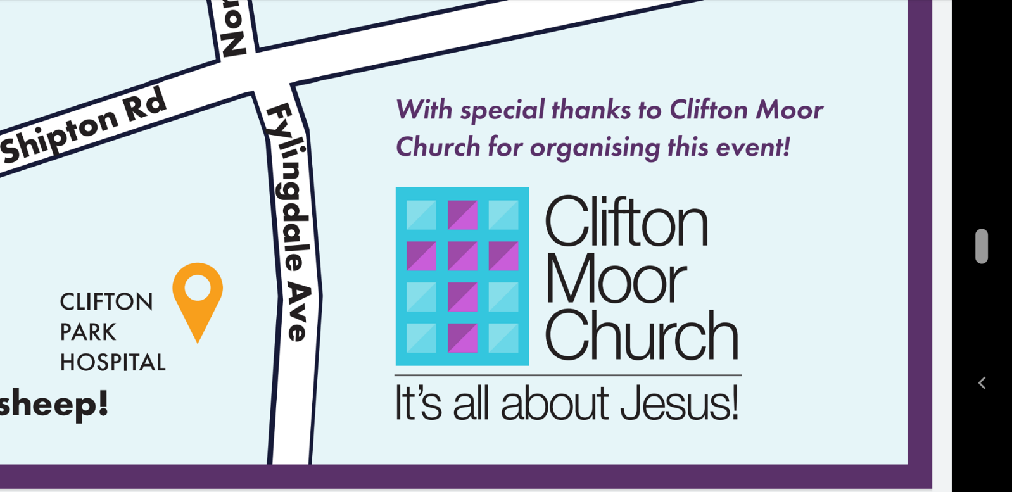

**Thank you for taking part in the CMC Nativity Sheep Trail.**

Have you found the names of all **27** sheep?

Have you written their names in the spaces?

Would you like to enter a prize draw?

**The CMC Nativity Sheep Trail is an activity run by Clifton Moor Church.**

So, what do you do now?

1/Clearly enter your details below.

2/ Email this and the Sheep names to [cmcccbookings@gmail.com](mailto:cmcccbookings@gmail.com) a photo of the sheets is fine.

Name: ………………………………………………………………………………..

Contact telephone number: ………………………………………………….

Email: ………………………………………………………………………………..

Date of Birth: ……………………………………………………………………..

**The sheep trail runs from 18th to 24th December 2020, please return all entries by**

**30th December 2020.**

**A prize draw will take place on 31st December 2020 and winners notified by email.**